**Task13-GPT**

**CSS Variables (Custom Properties)**

CSS variables, also known as **custom properties**, allow you to store values that can be reused throughout your stylesheet. This helps maintain consistency and makes it easier to update styles globally. Variables are defined using the -- syntax and can be accessed with the var() function.

**How CSS Variables Work**

1. **Define the Variable**: Variables are defined within a selector (often :root for global scope).
2. **Use the Variable**: Variables can be applied to any CSS property using the var() function.
3. **Change the Value**: Changing a variable’s value affects all elements using that variable.

**Example: Defining and Using CSS Variables**

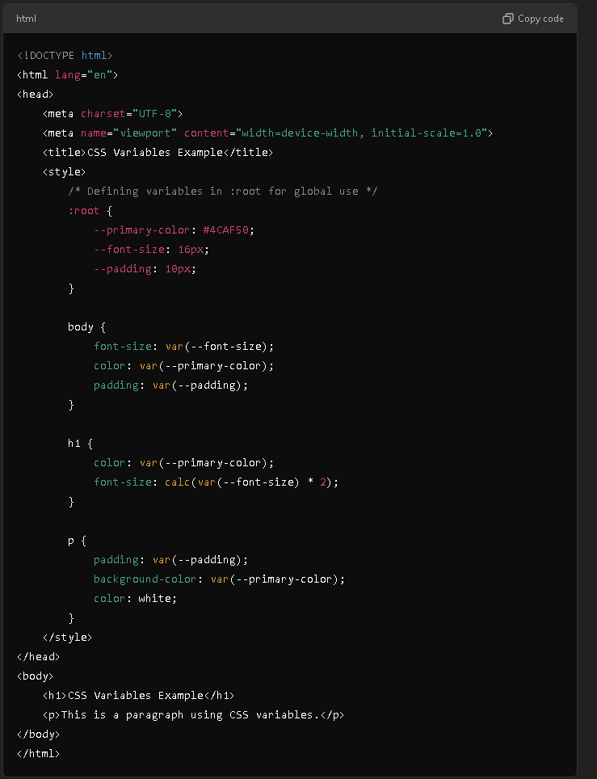

**Result   
 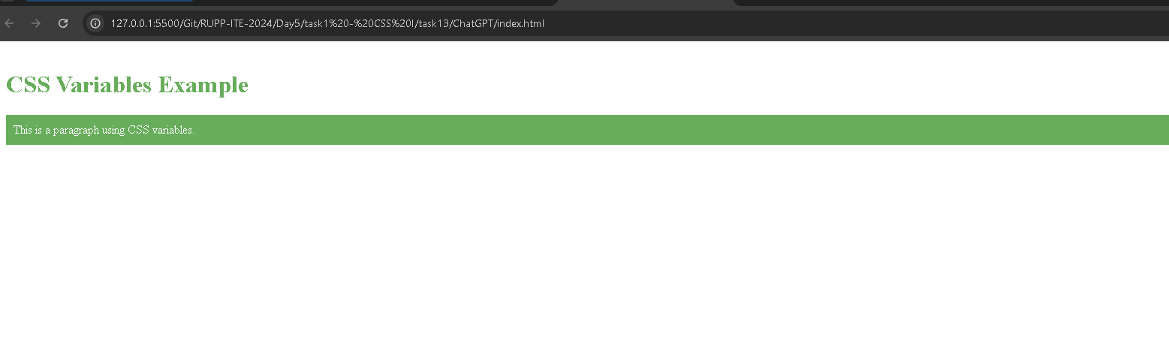**

**Explanation of the Example**

* **Variable Declaration**:
  + **--primary-color** sets the theme's primary color.
  + **--font-size** defines the base font size.
  + **--padding** sets padding.
* **Variable Usage**:
  + In **the body, h1,** and **p** elements, these variables are used for consistent styling.

**Changing Variable Values**

You can easily change the value of a CSS variable. For instance, if you change **--primary-color** to **#FF5733,** the text and background color of the entire page will update accordingly.

**Benefits:**

* **Consistency**: Ensures that repeated values like colors or spacing are uniform across the stylesheet.
* **Maintainability**: If you need to update a value (e.g., change the theme color), you only need to change the variable once.